# Tips for creating your own 32x32 color images

For example, let’s Google for images of a deer:

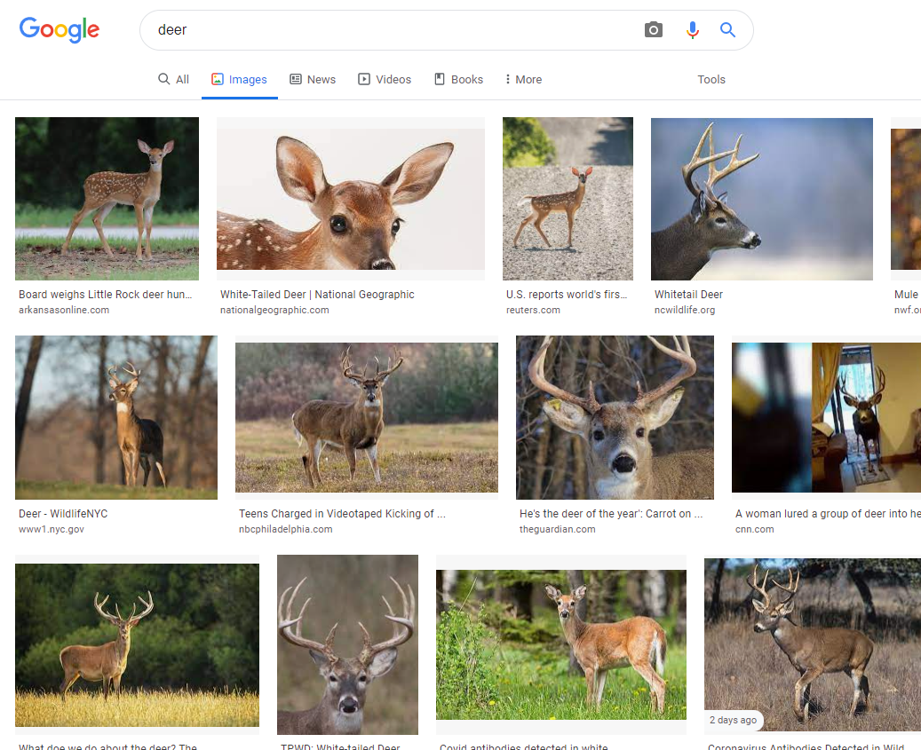

Download a picture to your computer. In this example, we’ll save the picture as deer.jpg

Run the python code from this website to convert the picture to 32x32 format:

<https://www.codegrepper.com/code-examples/python/resize+image+to+32x32+python>

#The following code should be run from the same image directory

from PIL import Image

image = Image.open("deer.jpg")

image = image.resize((32,32),Image.ANTIALIAS)

image.save(fp="deer32x32.jpg")

After you converted the file, check out its property by right-click on the converted image:

